**Software Design Document**

for

TalkBox

Group 15

York University

EECS2311 Software Development Project

24. March 2019

**Contents**

1. **Sequence Diagrams 2**
   1. TalkBox Configuration . . . . . . . . . . . . . . . . . . . . . . . . . . . . . . . . . . . . . . . . . . . . . . . . 2
   2. TalkBox Simulator . . . . . . . . . . . . . . . . . . . . . . . . . . . . . . . . . . . . . . . . . . . . . . . . . . . 13
   3. TalkBox Configuration Log (TBCLog) . . .. . . .. . . . . . . . . . . . . . . . . . . . . . . . . . . . . 15

**2. Class Diagrams 16**

**Sequence Diagrams**

**TalkBox Configuration**

**Record Audio:**



**Playback Audio from a Button:**



**Update Number of Buttons:**

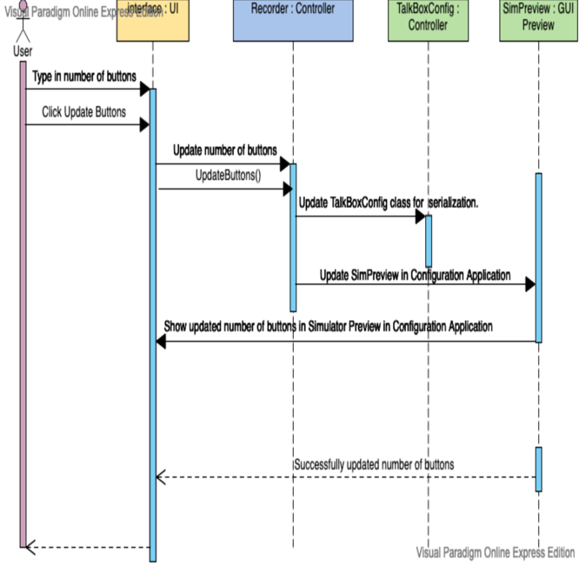

**Update Button Label:**

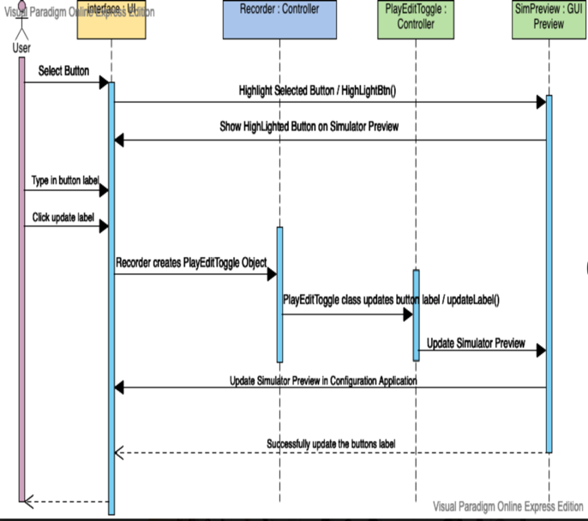

**Upload Audio to Buttons:**



**Upload Images to Buttons:**



**Swap Profiles:**



**Save Settings / Serialize Changes:**



**Launch TalkBox Simulator Application:**



**Load/Delete/New Profile:**



**Next/Previous Log:**



**TalkBox Simulator**

**Playback Audio from a Button:**

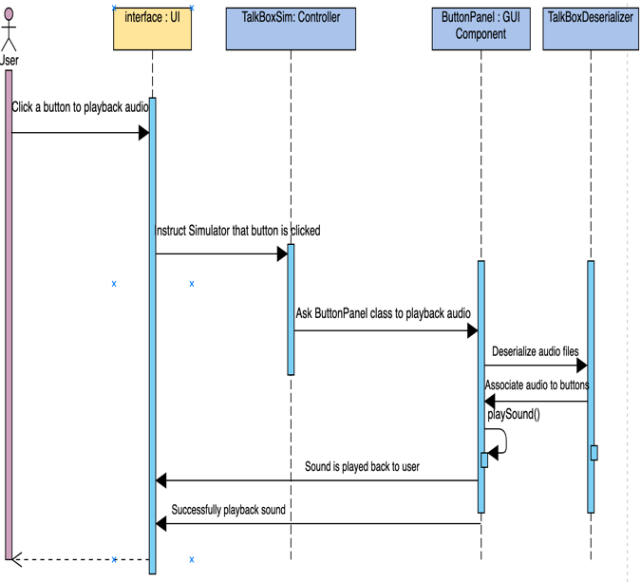

**Swap Profiles:**



**TalkBox Configuration Log (TBCLog)**

**Next/Previous/Load Log:**

